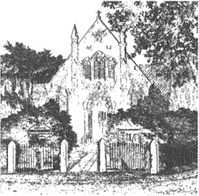
PLUMLEY WITH TOFT & BEXTON
PARISH COUNCIL
11th April 2026

Electors of the Parish of Plumley with Toft and Bexton Parish Council are invited to
The Annual Parish Meeting
To be held on Wednesday the 6th May 2026 at 8.30pm
Plumley Methodist Church

The meeting is convened under the provision of the Local government Act 1972 SEC (1) and 13 (1)

Agenda
- To receive the Annual Parish council report from the Chairman
- To discuss any other issues raised by any electors present

This meeting will take place following the Annual General Meeting of the Parish Council which will start at 7.00 pm
Plumley Methodist Church

David McGifford
Clerk to the Council
07968 603811

