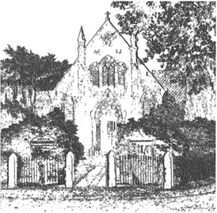
PLUMLEY WITH TOFT & BEXTON
PARISH COUNCIL
27th December 2025

Dear Councillor,

You are hereby requested to attend.

THE MEETING OF THE PARISH COUNCIL WHICH WILL BE HELD ON
WEDNESDAY 7th JANUARY 2026 at 7.30 pm, at PLUMLEY METHODIST CHURCH

David McGifford,
Clerk to the Parish Council.

Residents are encouraged to attend & members of the Press are welcome at our meetings however

the Press and Public may not speak when the Council is in session unless invited to do so by

the Chair.

Agenda
- Apologies
To receive apologies from Councillors unable to attend
- Declaration of interests
To receive from Councillors any declarations of pecuniary and non-pecuniary interests related to this agenda.
- Minutes
To approve & sign the Minutes of the previous meetings on the 12th November 2025
- Cheshire East Council Matters:
To receive a report on Cheshire East Council
- Clerks Report
  - Correspondence of note and to take decisions on items specified.
  - Reports of additional Road Traffic Accidents and near misses.
- Financial Payments –
6.1 To approve payments including salaries & expenses
6.2 To approve the balances in the Operational and Reserves Accounts
6.3 To approve the Budgets and precept for the Financial year 2026-27

To receive any comments and reports by Councilors concerning transport, planning, footpaths, highways, Village Hall, Parish Plan, Community Pride, Community Resilience, Home watch
Note - When receiving reports and making resolutions perceived risks need to be identified and if necessary agreed actions required to mitigate them.
- General Highways
  - Average speed camera update
  - Booths Bridge update
- Streetscape
To receive any updates on Streetscape projects
- Planning applications received to date
- 25/4430/PRIOR-1A An application for Prior Approval of a large householder extension at Singh House, Ascol Drive, WA16 0UD
- 25/4547/LBC Application for Listed Building Consent, the Smoker Inn, Chester Road WA16 0TY
- 25/4693/TPO, Community Woodland, Ascol Drive.

- Cheshire Oil Development
To receive any updates
- Police Liaison
- Toft Estate Fly Tipping incident update
- Note on PCSO’s circulated
- Footpaths

To receive any updates
- Meetings – To note feedback from meetings attended since the last meeting on the 12th November 2025
.
To receive any items for inclusion in the agenda for the next meeting

