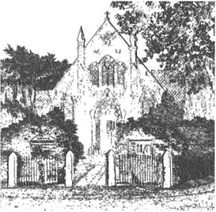
PLUMLEY WITH TOFT & BEXTON
PARISH COUNCIL
3rd November 2025

Dear Councillor,

You are hereby requested to attend.

THE MEETING OF THE PARISH COUNCIL WHICH WILL BE HELD ON
WEDNESDAY 12th November 2025 at 7.30 pm, at PLUMLEY METHODIST CHURCH

David McGifford,
Clerk to the Parish Council.

Residents are encouraged to attend & members of the Press are welcome at our meetings however

the Press and Public may not speak when the Council is in session unless invited to do so by

the Chair.
Agenda
- Apologies
To receive apologies from Councillors unable to attend
- Declaration of interests
To receive from Councillors any declarations of pecuniary and non-pecuniary interests related to this agenda.
- Minutes
To approve & sign the Minutes of the previous meetings on the 10th September 2025
- Cheshire East Council Matters:
To receive a report on Cheshire East Council
- Clerks Report
  - Correspondence of note and to take decisions on items specified.
  - Reports of additional Road Traffic Accidents and near misses.
- Financial Payments –
6.1 To approve payments including salaries & expenses
6.2 To approve the balances in the Operational and Reserves Accounts
- To receive any comments and reports by Councilors concerning transport, planning, footpaths, highways, Village Hall, Parish Plan, Community Pride, Community Resilience, Home watch
Note - When receiving reports and making resolutions perceived risks need to be identified and if necessary agreed actions required to mitigate them.
- General Highways
  - Average speed camera update
  - Booths Bridge update
- Streetscape
To receive any updates
- Planning applications received to date
- 25/3632/CLPUD Application for a Certificate of Lawful Use, Peover End, Plumley Moor Road, WA16 9SE.

- 25/3196/DSC Application for the discharge of a variety of conditions, Hollyhedge Farm, Middlewich Road, Toft WA 16 9PG

- RE: 25/3989/HOUS Householder 16 Maltkiln Road, Plumley, Knutsford, Cheshire East, WA16 0TS

- 25/4127/VOC Variation of Condition Site address: Oak Cottage Merry Farm Drive, Plumley, Knutsford, Cheshire East, WA16 9TD

- Cheshire Oil Development
To receive any updates
- Police Liaison
To receive any updates
- Footpaths

To receive any updates
- Meetings – To note feedback from meetings attended since the last meeting on the 10th September 2025
.
To receive any items for inclusion in the agenda for the next meeting

