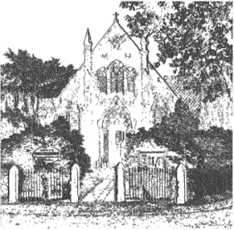
PLUMLEY WITH TOFT & BEXTON
PARISH COUNCIL
2nd January 2024
Dear Councillor,

You are hereby requested to attend,

THE MEETING OF THE PARISH COUNCIL WHICH WILL BE HELD ON
WEDNESDAY 10th January 2024 starting at 7.30 pm
PLEASE NOTE THAT THE MEETING WILL BE HELD AT PLUMLEY METHODIST CHURCH ON PLUMLEY MOOR ROAD
To be conducted in accordance with the attached Agenda
- The public and press are welcome to attend the meeting, please note that there will be 15 minutes at each meeting to receive any questions from members of the public, either verbally or in writing including those which have been received in writing 7 days prior to the meeting.

- There maybe confidential items towards the end of the meeting which the law requires the council to make a resolution to exclude the public and the press in accordance with Section 100(B) (2) of the Local Government Act 1972

David McGifford
David McGifford, Clerk to the Parish Council.

e-mail clerk@plumley-toft-bexton-pc.co.uk telephone 07968 603811

Meeting Agenda
- Apologies To receive and accept apologies for absence from those members unable to attend.

- Declaration of interests
To receive from Councillors any declarations of pecuniary and non-pecuniary interests
- Minutes To approve & sign the Minutes of the meetings held on the 1st and 11th of November 2023

- Co Option of a councilor
To agree the co option of a councilor for the Plumley Ward
- Cheshire East Council Matters:
To receive a report on Cheshire East Council
- Clerks Report
  - Correspondence and to take decisions on items where necessary
  - Reports of additional Road Traffic Accidents and near misses
Financial Payments –
  - To approve payments. Includes: Salaries & expenses.
  - To approve the balances in the Community and Business accounts.
  - To approve the budget / precept for 2024-25
- To receive any comments and reports by Councilors concerning transport, planning, footpaths, highways, Village Hall, Parish Plan, Community Pride, Community Resilience, Home watch
Note - When receiving reports and making resolutions perceived risks need to be identified and if necessary agreed actions required to mitigate them
- General Highways issues – To receive any updates

- Average Speed Camera Scheme To receive any updates

- Planning To review current planning applications
- Cheshire Oil Development To receive any updates
- Police Liaison To receive any updates
- Footpaths To receive any updates
- Meetings – To note feedback from meetings attended since the last meeting on the 11th of November 2023

- To receive any items for inclusion in the agenda for the next meeting Wednesday 6th March 2024

