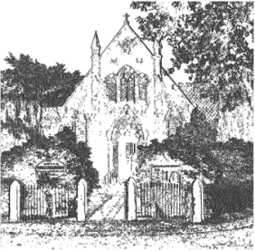
PLUMLEY WITH TOFT & BEXTON
PARISH COUNCIL
11th May 2023
MINUTES OF THE MEETING OF THE PARISH COUNCIL HELD ON
WEDNESDAY THE 10th May 2023 at 7.30 pm
Councillors in attendance:
A Gabbott (Chair) G Coates (Vice Chair) A Shaw, Anne Thompson, V L Roxby , J Wright and A Harrison CEC
Minutes
- Apologies were received from Cllrs Crossman, Jones and Nichols

- Declaration of interests- There were no declarations of pecuniary or non-pecuniary interests related to this agenda
- Financial Payments – To approve payments. Includes: Salaries & expenses.

 | Payments
 | Mr C Wilson HS2 representation expenses -London | 112.00

PTB/01/2324 Resolved to approve the payment for Mr C Wilson whilst noting that cheque number 101362 has been cancelled (C Wilson £92)

- To approve the application for the borrowing of £28,225 from the MHCLG /Secretary of States for the Average Speed Camera Project

PTB/ 02/2324 Resolved to approve the application for the borrowing of £28,225 from the MHCLG /Secretary of States for the Average Speed Camera Project.

- To note the signing of the contract with the Police and Crime Commissioners Office for the Average Speed Camera Project

FTB/03/2324 Resolved to note the Clerks signing of the Contract with the Police and Crime Commissioners Office for the Average Speed Camera Project

- FTB /04/2324 Resolved to approve the Minutes of this meeting on the 10th May 2023

A Gabbott - Chair

