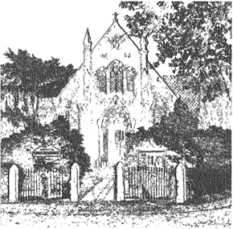
PLUMLEY WITH TOFT & BEXTON
PARISH COUNCIL
30th April 2023
Dear Councillor,
You are hereby requested to attend
THE MEETING OF THE PARISH COUNCIL WHICH WILL BE HELD ON
WEDNESDAY THE 10th May 2023 at 7.30 pm
PLEASE NOTE THAT THE MEETING WILL BE HELD AT PLUMLEY METHODIST CHURCH ON PLUMLEY MOOR ROAD
To be conducted in accordance with the attached Agenda
David McGifford
David McGifford, Clerk to the Parish Council.
e-mail clerk@plumley-toft-bexton-pc.co.uk telephone 07968 603811

The Press and Public may not speak when the Council is in session unless invited to do so by the Chairman.
Public Forum 7.30 pm - Public comments will be taken before the meeting commences but are restricted to 15 minutes unless the Chairman allows otherwise.

Meeting Agenda
- Apologies To receive and accept apologies for absence from those members unable to attend.
- Declaration of interests
To receive from Councillors any declarations of pecuniary and non-pecuniary interests related to this agenda
- Financial Payments – To approve payments. Includes: Salaries & expenses.

 | Payments
 | Mr C Wilson HS2 representation expenses -London | 112.00

- To approve the application for the borrowing of £28,225 from the MHCLG /Secretary of States for the Average Speed Camera Project

- To note the signing of the contract with the Police and Crime Commissioners Office for the Average Speed Camera Project

