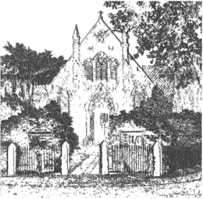
PLUMLEY WITH TOFT & BEXTON
PARISH COUNCIL
6th September 2022

MINUTES OF THE MEETING OF THE PARISH COUNCIL HELD ON
WEDNESDAY 31st AUGUST 2022 at 7.30 pm PLUMLEY METHODIST CHURCH

Councillors in Attendance – A Gabbott (Chair) G Coates (Vice Chair) A Thomson, S Jones J Wright, R Raphael

Meeting Agenda
- Apologies To receive and accept apologies for absence from those members unable to attend.
Apologies were received from S Wharfe, V L Roxby, S Crossman, A Shaw and D Nichols.
- Declaration of interests
There were no declarations of interest
- Planning To review current planning applications
22/2715M LAND OFF BEGGARMANS LANE, KNUTSFORD
PTB/18/2223 resolved to OBJECT on the grounds of it being a nuisance to local residents in terms of noise generated by users, vehicles and dogs. It is on the greenbelt and there are no facilities / toilets provided for users.
- Close

