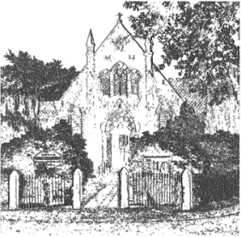
PLUMLEY WITH TOFT & BEXTON
PARISH COUNCIL
27th August 2022
Dear Councillor,

You are hereby requested to attend

THE MEETING OF THE PARISH COUNCIL WHICH WILL BE HELD ON
WEDNESDAY 31st AUGUST 2022 at 7.30 pm
PLEASE NOTE THAT THE MEETING WILL BE HELD AT PLUMLEY METHODIST CHURCH ON PLUMLEY MOOR ROAD
To be conducted in accordance with the attached Agenda

David McGifford
David McGifford, Clerk to the Parish Council.

e-mail clerk@plumley-toft-bexton-pc.co.uk telephone 07968 603811

The Press and Public may not speak when the Council is in session unless invited to do so by the Chairman.
Public Forum 7.30 pm - Public comments will be taken before the meeting commences but are restricted to 15 minutes unless the Chairman allows otherwise.

Meeting Agenda
- Apologies To receive and accept apologies for absence from those members unable to attend.
- Declaration of interests
To receive from Councillors any declarations of pecuniary and non-pecuniary interests related to this agenda
- Planning To review current planning applications
22/2715M LAND OFF BEGGARMANS LANE, KNUTSFORD
- CLOSE

