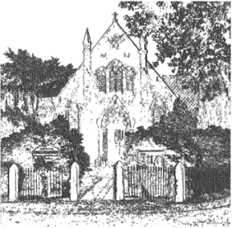
PLUMLEY WITH TOFT & BEXTON
PARISH COUNCIL
9th October 2020

MINUTES OF THE MEETING OF THE PARISH COUNCIL HELD ON
WEDNESDAY 7th October 2020 at 8.00 pm
Remote meeting via Zoom - to join
Meeting ID: 896 1018 1086
Passcode: 538927
Cllrs in attendance:
G Coates (Chairing the meeting) D Nichols, S Wharfe, S Jones, J Wright, V L Roxby,
S Crossman, A Thompson, R Raphael, M Asquith CEC

- Apologies
To receive and accept apologies for absence from those members unable to attend.
Apologies were received from Cllrs A Gabbott and A Shaw
- Declaration of interests
To receive from Councillors any declarations of pecuniary and non-pecuniary interests

Non related to this meeting

- Road Closure Sudlow Lane, Tabley Superior

To agree proposed delegated authority for handling issues relating to the potential impact of the Sudlow Lane Road Closure

PTB/22/1920 Resolved to delegate the authority to Cllr D Nichols, supported by G Coates to generate information for the Clerk on matters relating to the closure of Sudlow Lane

