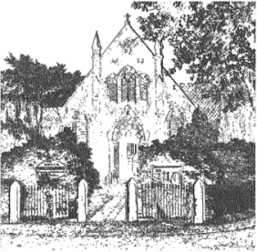
PLUMLEY WITH TOFT & BEXTON
PARISH COUNCIL
28th August 2019
Dear Councillor,

You are hereby requested to attend

THE MEETING OF THE PARISH COUNCIL
WHICH WILL BE HELD ON
WEDNESDAY 4th September 2019 at 7.30 pm Plumley Village Hall

To be conducted in accordance with the Agenda attached.

David McGifford
David McGifford, Clerk to the Parish Council.

Residents are encouraged to attend & members of the Press are welcomed.

The Press and Public may not speak when the Council is in session unless invited to do so by the Chairman.
Public Forum 7.30 pm - Public comments will be taken before the Meeting commences but are restricted to 15 minutes unless the Chairman allows otherwise.

Public Forum

Police Surgery to be confirmed

Meeting Agenda
- Apologies;
To receive and accept apologies for absence from those members unable to attend.
- Declaration of interests
To receive from Councillors any declarations of pecuniary and non-pecuniary interests

- Minutes
To approve & sign the Minutes of the meeting held on the 26th June 2019

- Cheshire East Council Matters:
To receive a report on Cheshire East Council

- Recognition of past Councillors
An open discussion on this matter

- Clerks Report – To receive
  - Correspondence and to take decisions on items specified in Appendix 09/19 attached
  - Reports of additional Road Traffic Accidents
- Financial Payments –
  - To approve payments in Appendix 09/19 attached. Includes: Salaries & expenses.

- Co Option of a Councillor
To review interest for the position of Councillor
- To receive any comments and reports by Councilors concerning transport, planning, footpaths, highways, Village Hall, Parish Plan, Community Pride, Community Resilience, Home watch
Note - When receiving reports and making resolutions perceived risks need to be identified and if necessary agreed actions required to mitigate them
  - General Highways issues, including Speedwatch –GC
- Action log
- Speedwatch and speeding initiatives update
  - Planning JW
- 19/3749M 26, HOLLYTREE ROAD, PLUMLEY, CHESHIRE, WA16 0UJ
  - Cheshire Oil Development update DN
  - Neighbourhood Planning SJ
  - Footpaths AS/VRL
  - Police Liaison SC/VRL
- Meetings – To note feedback from meetings attended since the meeting 26th June 2019 and to note attendance to take place at meetings during September and October 2019

- To receive any items for inclusion in the agenda for the next meeting, proposed to be held at 7.30pm on Wednesday 6th November 2019 in the Committee Room at Plumley Village Hall
- Close Meeting

