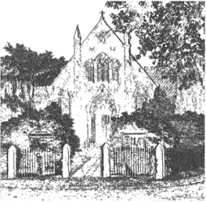
PLUMLEY WITH TOFT & BEXTON
PARISH COUNCIL
23rd May 2018

MINUTES OF THE EMERGENCY MEETING OF THE PARISH COUNCIL HELD ON
WEDNESDAY 6th June 2018 7.30pm

Councillors in attendance: A Gabbott Chair C Wilson V R Lecester, D Nichols, J Wright, A Thomson, S Crossman A Shaw, H Lawton
Agenda
- Apologies;
To receive and accept apologies for absence from those members unable to attend.
Apologies were received from G Coates

- Declaration of interests
To receive from Councillors any declarations of pecuniary and non-pecuniary interests
Cllr D Nichols, S Crossman declared an interest in Plumley Village Hall

- Annual Accounts
To approve the Annual Governance and Accountability Return for 2017/18
Council Resolved to approve the Annual Governance and Accountability Return for 2017/18

- Close of meeting

