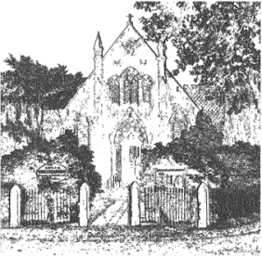
PLUMLEY WITH TOFT & BEXTON
PARISH COUNCIL
26th July 2018

MINUTES OF THE MEETING OF THE PARISH COUNCIL
WEDNESDAY 1st August 2018 7.30pm
PLUMLEY METHODIST CHURCH

In attendance: Cllrs C Wilson (Chairman for the meeting) J Wright, D Nichols. H Lawton, Mrs A Thomson, Mrs S Crossman, A Shaw, S Wharfe
Public Session
There were 3 members of the public in attendance who wished to make comment against planning application 18/3467M TROUTHALL LANE,

Agenda
- Apologies;
To receive and accept apologies for absence from those members unable to attend.
Apologies were received from Cllrs A Gabbott, G Coates and G Walton CEC

- Declaration of interests
To receive from Councillors any declarations of pecuniary and non-pecuniary interests
There were no declarations of interest

- Planning Applications

To review the following planning applications

- 18/3251M Sandbeck Stables, ULLARD HALL LANE, PLUMLEY
The Council resolved to not object to this proposal

- 17/4545M Holly Tree Farm, Plumley Moor Road, Plumley, WA16 9RU
The Council resolved to pass no comment

- 18/3467M TROUTHALL LANE, PLUMLEY, CHESHIRE, WA16 0UN
The Council resolved to object on the following grounds –
The rear elevation two-storey wall with large areas of glazing, approximately 1 m away from the rear boundary, faces the private rear gardens of the property behind, is obtrusive, overbearing, and unnecessary, (roof lights could be provided to give the necessary light over the stairs and landing. There is also a risk of fire spreading due to the large unprotected areas of glazing, so close to a boundary.
2. No rear gardens are shown on the plans or private garden areas suitable for sitting out, to provide adequate amenity areas for The Cottage, or the proposed new dwelling, even though there is the possibility of providing this, particularly without the ‘garage’.
3. The former garage is not shown as being used as a garage or having alteration so could be suitable for a garage on the plans, and its use is therefore unknown, this should be established, without the garage there is only sufficient parking for two cars to the new house.
4. If planning permission is to be given it may be appropriate to remove Permitted Development Rights, or have legal agreement with regard to important features such as frosted glass, or use of the garage
5. Over development of the site

18/0769M GWYNANT, PLUMLEY MOOR ROAD, PLUMLEY, WA16 0TR

The Council resolved to not object to this proposal

- Close of meeting

