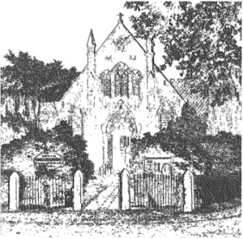
PLUMLEY WITH TOFT & BEXTON
PARISH COUNCIL
26th July 2018

MEETING OF THE PARISH COUNCIL TO BE HELD ON
WEDNESDAY 1st August 2018 7.30pm
PLUMLEY METHODIST CHURCH

Agenda
- Apologies;
To receive and accept apologies for absence from those members unable to attend.

- Declaration of interests
To receive from Councillors any declarations of pecuniary and non-pecuniary interests

- Planning Applications

To review the following planning applications

- 18/3251M Sandbeck Stables, ULLARD HALL LANE, PLUMLEY
- 17/4545M Holly Tree Farm, Plumley Moor Road, Plumley, WA16 9RU
- 18/2894M 11, TROUTHALL LANE, PLUMLEY, CHESHIRE, WA16 0UN

- Close of meeting

