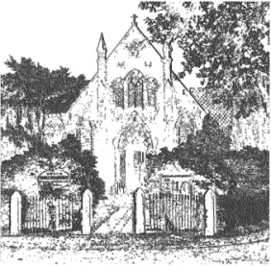
PLUMLEY WITH TOFT & BEXTON
PARISH COUNCIL
26th July 2018

MEETING OF THE PARISH COUNCIL TO BE HELD ON
WEDNESDAY 1st August 2018 7.30pm
PLUMLEY METHODIST CHURCH

Public Session
Up to 15 minutes is allowed for members of the public to comment on items on this agenda

Agenda
- Apologies;
To receive and accept apologies for absence from those members unable to attend.

- Declaration of interests
To receive from Councillors any declarations of pecuniary and non-pecuniary interests

- Planning Applications

To review the following planning applications

- 18/3251M Sandbeck Stables, ULLARD HALL LANE, PLUMLEY
- 17/4545M Holly Tree Farm, Plumley Moor Road, Plumley, WA16 9RU
- 18/3467M TROUTHALL LANE, PLUMLEY, CHESHIRE, WA16 0UN

- Close of meeting

