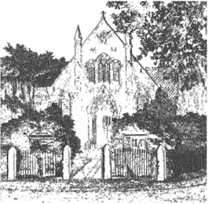
PLUMLEY WITH TOFT & BEXTON
PARISH COUNCIL
23rd May 2018

EMERGENCY MEETING OF THE PARISH COUNCIL TO BE HELD ON
WEDNESDAY 6th June 2018

Agenda
- Apologies;
To receive and accept apologies for absence from those members unable to attend.

- Declaration of interests
To receive from Councillors any declarations of pecuniary and non-pecuniary interests

- Annual Accounts
To approve the Annual Governance and Accountability Return for 2017/18

- Close of meeting

