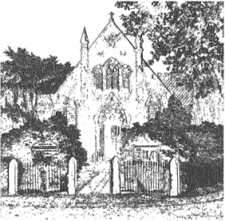
PLUMLEY WITH TOFT & BEXTON
PARISH COUNCIL
19th April 2017

Electors of the Parish of Plumley with Toft and Bexton Parish Council are invited to
The Annual Parish Meeting
To be held on Wednesday the 3rd May 2017 at 8.30pm
At
Plumley Village Hall

The meeting is convened under the provision of the Local government Act 1972 SEC (1) and 13 (1)

Cllr. Anthony Gabbott
Chairman of Plumley with Toft with Bexton Parish Council
Agenda
- To receive the Annual Parish council report from the Chairman
- To discuss any other issues raised by an elector present

This meeting will take place following the Annual General Meeting of the Parish Council which will start at 7.00pm at Plumley Methodist Church

